Beyond Accuracy: An Analytical Evaluation of Cross-Dataset Generalisation in Retinal OCT Classification Using a CNN–SE Model

Abstract
Deep-learning systems for retinal optical coherence tomography (OCT) classification often report high accuracy on benchmark datasets. However, a high score on a single test set does not by itself establish reliable generalisation, well-calibrated confidence, or readiness for clinical use. This study presents an analytical evaluation of a CNN with Squeeze-and-Excitation (CNN–SE) blocks trained on the eight-class OCT-C8 dataset and evaluated on a four-class OCT2017 test set without fine-tuning. The evaluation contains 968 images, with 242 images in each target class. The model correctly classified 962 images, achieving 99.38% accuracy, a macro F1-score of 99.38%, and a macro one-versus-rest ROC-AUC of 0.99992. Across five independent training seeds, the mean accuracy is 99.28% (standard deviation 0.10 percentage points), with a range of 99.17%–99.38%. An additional analysis of per-image predictions found 15 images misclassified by at least one seed, while one image was misclassified in all five runs. Predicted labels differed across seeds for 14 images. The six errors in the primary model evaluation are examined by class and confidence. Calibration results show a low expected calibration error of 0.0246, but a maximum calibration error of 0.2485 in a sparsely populated confidence bin. The computational benchmark indicates a compact parameter count, though the proposed model requires a higher FLOP count than the three compared mobile architectures. The results demonstrate high classification accuracy on the evaluated external test set, while also identifying limits in the breadth of external validation, confidence reliability, computational benchmarking, and clinical interpretation.
Keywords: optical coherence tomography; retinal disease classification; cross-dataset generalisation; Squeeze-and-Excitation; calibration; error analysis; reproducibility

1. Introduction
Optical coherence tomography provides cross-sectional images of retinal structures and is widely used in the assessment of retinal disorders. Deep-learning methods have been applied to classify OCT images into disease categories. The OCT2017 benchmark popularized the use of large-scale OCT images for distinguishing choroidal neovascularisation (CNV), diabetic macular oedema (DME), drusen, and normal scans [1]. Subsequent studies have explored convolutional neural networks, attention mechanisms, transfer learning, and lightweight architectures.
Reported accuracy remains an incomplete measure of practical reliability. A model may perform well on a familiar test distribution but degrade when images are obtained using different devices, protocols, populations, or preprocessing pipelines, a phenomenon well-documented in medical imaging AI [2]. External testing is therefore important, but a single external dataset still represents only a limited sample of possible clinical variation. In addition, accuracy alone does not describe the types of errors made, the reliability of predicted probabilities, or the computational cost of inference.
The related study by Dave, Domadiya, and Patel introduced a lightweight CNN–SE architecture for OCT classification and reported cross-dataset testing from OCT-C8 to OCT2017 [3]. In this study, we evaluate a lightweight CNN–SE architecture for OCT classification to assess its cross-dataset generalisation from OCT-C8 to OCT2017. Rather than solely reporting top-line metrics, we analyse repeated-seed variation, class-wise errors, calibration, and computational measurements. We use these results to identify what can and cannot be concluded from the current evidence.
The study addresses the following questions:
- How consistently does the saved CNN–SE workflow perform when trained on OCT-C8 and evaluated on the available OCT2017 test subset?
- What do class-wise errors and confidence-calibration measures reveal beyond overall accuracy?
- What can the current computational benchmark establish, and what comparisons remain incomplete?
- Which additional evaluations would provide the strongest evidence for generalisation and potential clinical relevance?
The intended contribution is analytical and reporting-focused. It aims to provide a transparent interpretation of the results, identify methodological constraints, and formulate a practical future research agenda.

2. Related Work

2.1 OCT image classification
Kermany et al. demonstrated the use of deep learning for medical diagnosis from retinal OCT images and provided a widely used four-class OCT benchmark [1]. Later work has considered CNN-based classifiers, attention mechanisms, hybrid networks, and lightweight models. These studies establish that OCT images contain features that can support automated classification. However, high performance on one benchmark should not be equated with performance across clinical settings.

2.2 Channel attention and CNN–SE models
Squeeze-and-Excitation blocks recalibrate channel-wise feature responses by modelling dependencies between feature channels [4]. They are an established attention mechanism. Their use in a CNN does not, by itself, establish architectural novelty, but rather provides a robust mechanism for feature refinement.

2.3 Reporting reliability in medical imaging AI
The CLAIM 2024 update recommends transparent reporting of data sources, reference standards, model development, evaluation, uncertainty, and limitations in medical-imaging AI studies [5]. In line with this guidance and the broader need for uncertainty quantification in medical decision-making [6], [7], this manuscript separates the single-model result from repeated-seed results, reports the evaluated sample and class mapping, and avoids interpreting one test set as proof of broad clinical generalisation.

2.4 Positioning of the present study
The current analysis is not a direct comparison against all published OCT classifiers. It is a focused audit of a CNN–SE workflow using saved predictions and benchmark outputs. Comparisons across studies must account for dataset version, image split, class mapping, preprocessing, model selection, and evaluation code. Vijayan et al. (2026) [8] report 99.90% accuracy on the same 968-image Kermany OCT2017 Version 2 test split and include duplicate-image checking, calibration, perturbation robustness, uncertainty, interpretability, and statistical analyses. Their findings provide valuable context regarding performance on this test split; however, differences in model architecture, preprocessing, and output restriction preclude a direct head-to-head comparison with our model..

3. Materials and Methods

3.1 Study design
The model was developed in a Python environment, utilizing standard deep-learning frameworks for training and validation. To rigorously assess cross-dataset generalisation, model weights were frozen after training on the primary dataset. The evaluation pipeline systematically generated predictions and confidence probabilities for the external dataset across multiple initialisation seeds, ensuring all reported metrics reflect the model's uncalibrated, zero-shot transfer capabilities.

3.2 Training dataset and model
The training uses OCT-C8, an eight-class dataset with the categories AMD, CNV, CSR, DME, DR, DRUSEN, MH, and NORMAL. It specifies an input size of 224 × 224 pixels, a batch size of 32, a maximum of 60 epochs, AdamW with a learning rate of 3 × 10⁻⁴ and weight decay of 10⁻⁴, label smoothing of 0.05, dropout of 0.30, and an SE reduction ratio of 4. Early stopping and best-validation checkpoint selection are implemented.
The model is a custom CNN with four convolutional blocks. Each block contains two 3 × 3 convolutional layers, batch normalisation, ReLU activations, an SE block, and max pooling. The architecture then uses global average pooling and a softmax classification head. Preprocessing includes grayscale loading, median filtering, CLAHE contrast enhancement, aspect-ratio-preserving resize with padding, scaling to [0,1], and replication to three channels. Mild geometric and intensity augmentation is applied only during training.

3.3 External evaluation and class mapping
The external evaluation uses 968 OCT2017 images. The four evaluated classes are CNV, DME, DRUSEN, and NORMAL, with 242 images per class. The model has eight output classes. The evaluation selects the four corresponding outputs and renormalises the selected probabilities before four-class prediction. The output indices recorded in the configuration are 1, 3, 5, and 7. No training or fine-tuning is performed during this external evaluation.
This class-mapping step is central to interpreting the result. The reported four-class accuracy is not the unmodified top-1 accuracy across all eight model outputs.

3.4 Metrics
The outputs report accuracy, macro and weighted precision, recall and F1-score, macro one-versus-rest ROC-AUC, Matthews correlation coefficient (MCC), Cohen's kappa, and a Wilson confidence interval for accuracy. We also computed bootstrap confidence intervals for macro F1 and macro ROC-AUC. Calibration is summarised using expected calibration error (ECE), maximum calibration error (MCE), and the multiclass Brier score [9]. The calibration uses six confidence bins, including bins with very small sample counts.

3.5 Repeated-seed evaluation
Five separate training runs were executed with seeds 11, 22, 33, 44, and 55. Each run evaluates 968 images from the same external test set. The mean and standard deviation across runs describe variation across training seeds under this evaluation setup.

4. Results

4.1 Single-model external test performance
The saved single-model evaluation contains 968 images. It records 962 correct predictions and 6 incorrect predictions. Accuracy is 99.38%. The Wilson 95% confidence interval is 98.65%–99.72%. Macro precision is 99.39%, macro recall is 99.38%, and macro F1-score is 99.38%. The macro one-versus-rest ROC-AUC is 0.99992. MCC is 0.99175, and Cohen's kappa is 0.99174.
Table 1. Overall classification performance metrics and correlation coefficients for the CNN–SE model evaluated on the 968-image OCT2017 test set.
Metric | Saved result
Images evaluated | 968
Correct / incorrect | 962 / 6
Accuracy | 99.38%
95% Wilson CI | 98.65%–99.72%
Macro precision | 99.39%
Macro recall | 99.38%
Macro F1-score | 99.38%
Macro ROC-AUC (OvR) | 0.99992
MCC | 0.99175
Cohen's kappa | 0.99174
Table 1 summarizes the aggregate classification metrics for the primary model evaluation, providing a comprehensive view of the model's discriminative ability on the external test set.
These results indicate high discrimination on the evaluated test subset. They do not establish generalisation to other external cohorts. The confidence interval describes sampling uncertainty under the assumptions of the interval calculation. It does not account for dataset shift or selection bias.
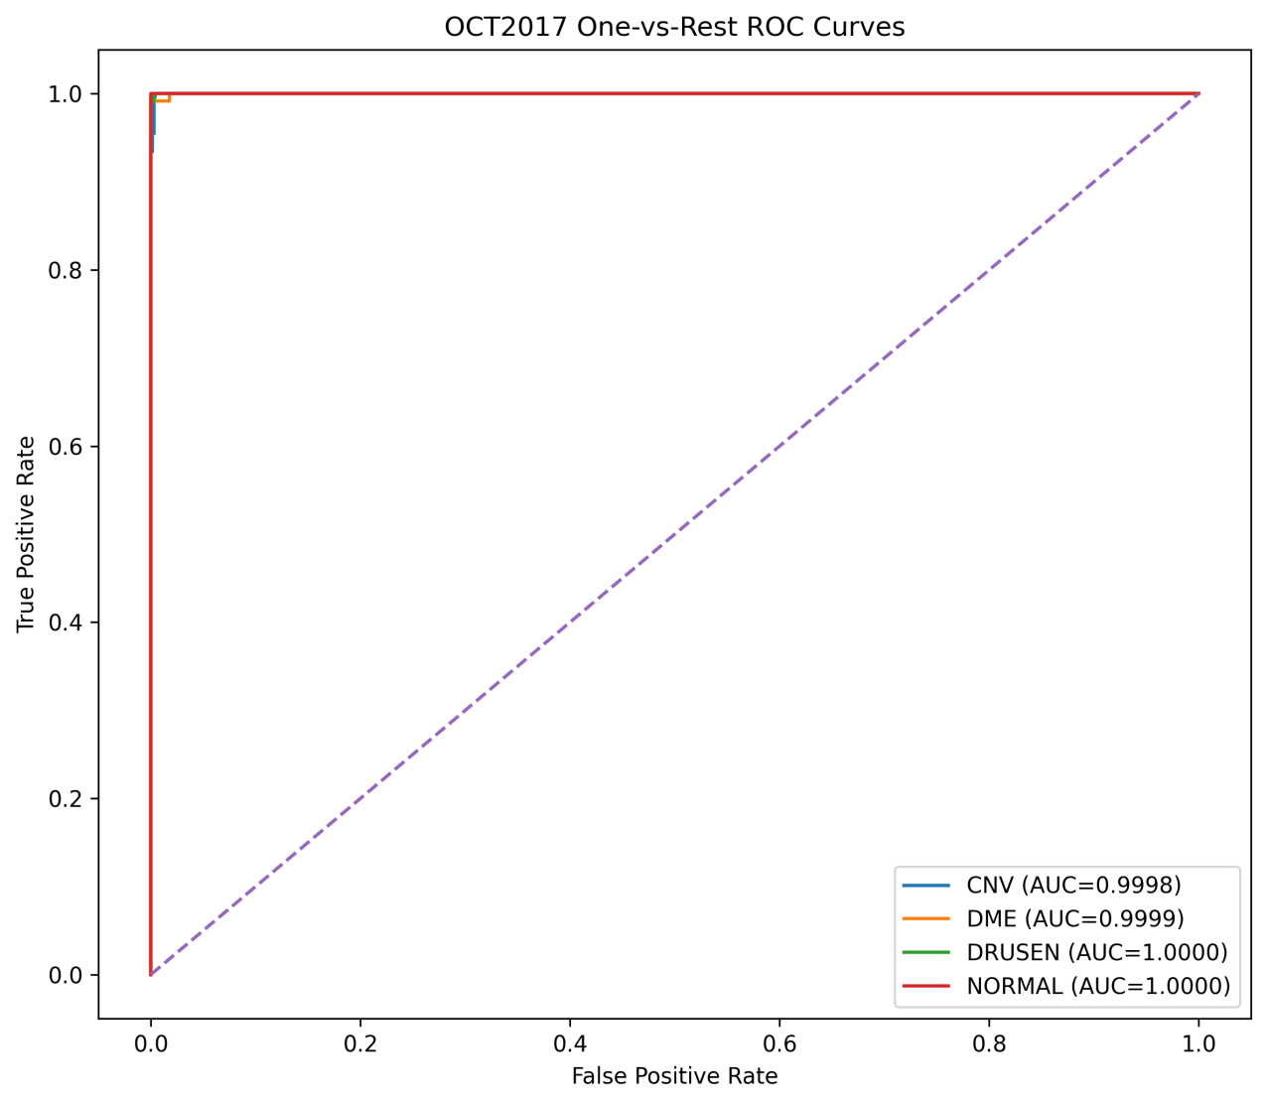
Figure 1. One-versus-rest Receiver Operating Characteristic (ROC) curves for the four evaluated classes (CNV, DME, DRUSEN, NORMAL) on the 968-image OCT2017 test set.

4.2 Class-wise performance and confusion matrix
To isolate specific areas of strength and potential failure, Table 2 details the precision, sensitivity, specificity, and F1-score for each of the four target disease categories.
Table 2. Class-wise evaluation metrics for CNV, DME, DRUSEN, and NORMAL categories
Class | n | Precision | Sensitivity | Specificity | F1-score
CNV | 242 | 98.37% | 100.00% | 99.45% | 99.18%
DME | 242 | 100.00% | 98.76% | 100.00% | 99.38%
DRUSEN | 242 | 99.17% | 99.17% | 99.72% | 99.17%
NORMAL | 242 | 100.00% | 99.59% | 100.00% | 99.79%
The confusion matrix is shown below. Rows represent reference classes and columns represent predicted classes.
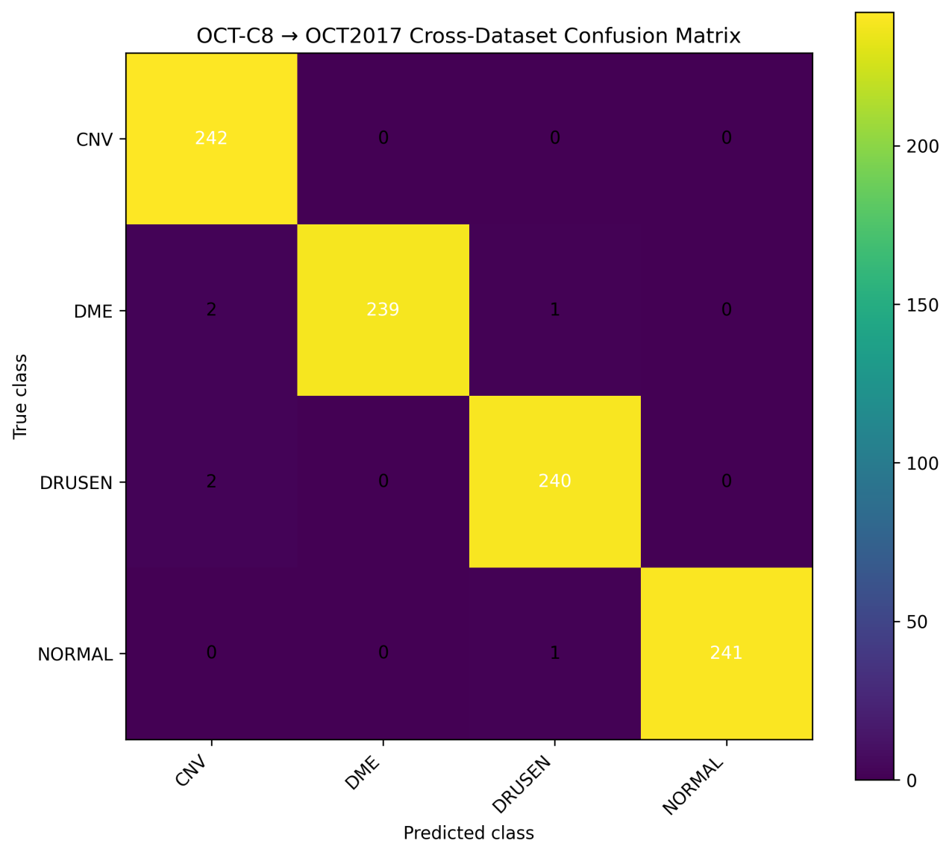
Figure 2. Confusion matrix detailing the cross-dataset performance (OCT-C8 to OCT2017).
The exact distribution of correct predictions and specific misclassification pathways is quantified in Table 3
Table 3. Cross-dataset confusion matrix comparing the model's predicted classes against the reference clinical labels
Reference class | Pred. CNV | Pred. DME | Pred. DRUSEN | Pred. NORMAL
CNV | 242 | 0 | 0 | 0
DME | 2 | 239 | 1 | 0
DRUSEN | 2 | 0 | 240 | 0
NORMAL | 0 | 0 | 1 | 241
All 242 CNV images were classified correctly. The DME class had three errors: two were classified as CNV and one as DRUSEN. The DRUSEN class had two errors, both classified as CNV. One NORMAL image was classified as DRUSEN. The small number of errors supports detailed qualitative review, but six examples are insufficient to characterise the full range of clinically relevant failure modes.

4.3 Five-seed results
Across the five runs, mean accuracy is 99.28% with a standard deviation of 0.10 percentage points. The range is 99.17%–99.38%. The observed run-to-run variation is small. However, all runs share the same 968-image evaluation set, providing evidence of seed-level stability rather than broader dataset robustness.

4.4 Cross-seed error consistency
To examine whether the five runs fail on the same images, the prediction files were aligned by image filename and reference class. All five files contained the same 968 images. Across the runs, 15 distinct images were misclassified at least once. Only one image, NORMAL-2182640-1.jpeg, was misclassified in every run. Four images were misclassified in four of the five runs, and two DRUSEN images were misclassified in three runs. The predicted class differed across seeds for 14 images. These results indicate that overall accuracy is stable, but a small set of difficult cases is sensitive to the training seed. The image that failed in every run warrants targeted expert review.
Table 4 presents the raw accuracy and total error counts for each independent training initialization, illustrating the stability of the architecture across different random seeds.
Table 4. Classification accuracy and aggregate error counts across five independent training seeds on the external evaluation set
Seed | Correct / 968 | Errors
11 | 960 / 968 | 8
22 | 961 / 968 | 7
33 | 960 / 968 | 8
44 | 962 / 968 | 6
55 | 962 / 968 | 6
Across all runs, 953 images were classified correctly by every seed. The remaining 15 images account for all seed-level errors, although not every one was misclassified in every run.

4.5 Single-model error and confidence analysis
Six errors are recorded in the single-model evaluation. Two DME images were assigned to CNV with confidence values of approximately 94.73% and 93.32%. One DME image was assigned to DRUSEN with a predicted probability of approximately 40.06%, close to the probability assigned to DME (39.76%). Two DRUSEN images were assigned to CNV with confidence values of approximately 66.87% and 60.90%. One NORMAL image was assigned to DRUSEN with confidence of approximately 55.30%. This pattern suggests that some errors are made with high confidence, while others occur between classes with similar predicted probabilities. A future analysis should assess whether these cases reflect ambiguous morphology, image artefacts, dataset labelling, or a preprocessing effect.
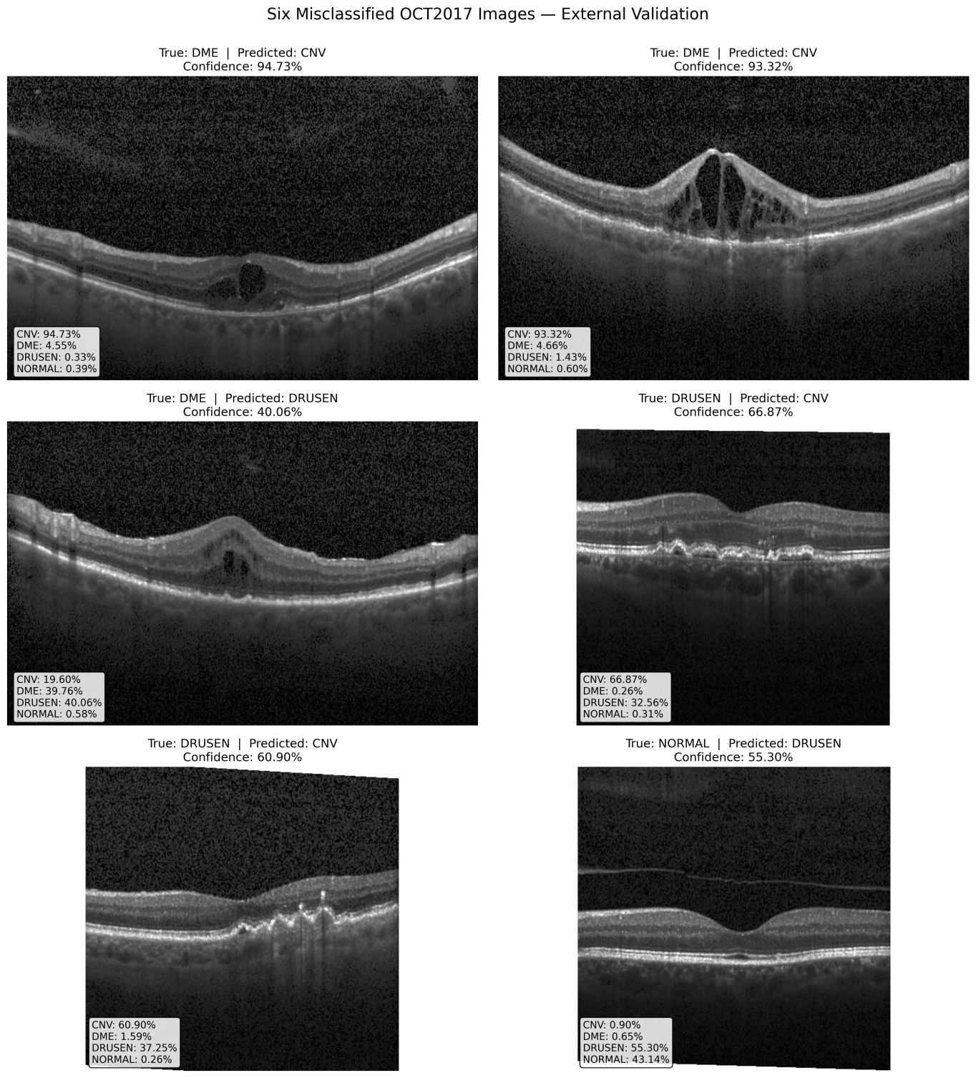
Figure 3. Morphological review of the six misclassified images from the single-model external validation. Subplots display the true label, predicted label, and the model's confidence distribution across all four classes.

4.6 Calibration
The expected calibration error is 0.0246, the maximum calibration error is 0.2485, and the multiclass Brier score is 0.0111. The calibration table shows that 926 of 968 images fall in the 0.9–1.0 confidence bin. The MCE of about 0.2485 occurs in the 0.7–0.8 bin, which contains six images. This small bin makes the maximum value sensitive to individual observations. The ECE is also dependent on the chosen binning scheme.
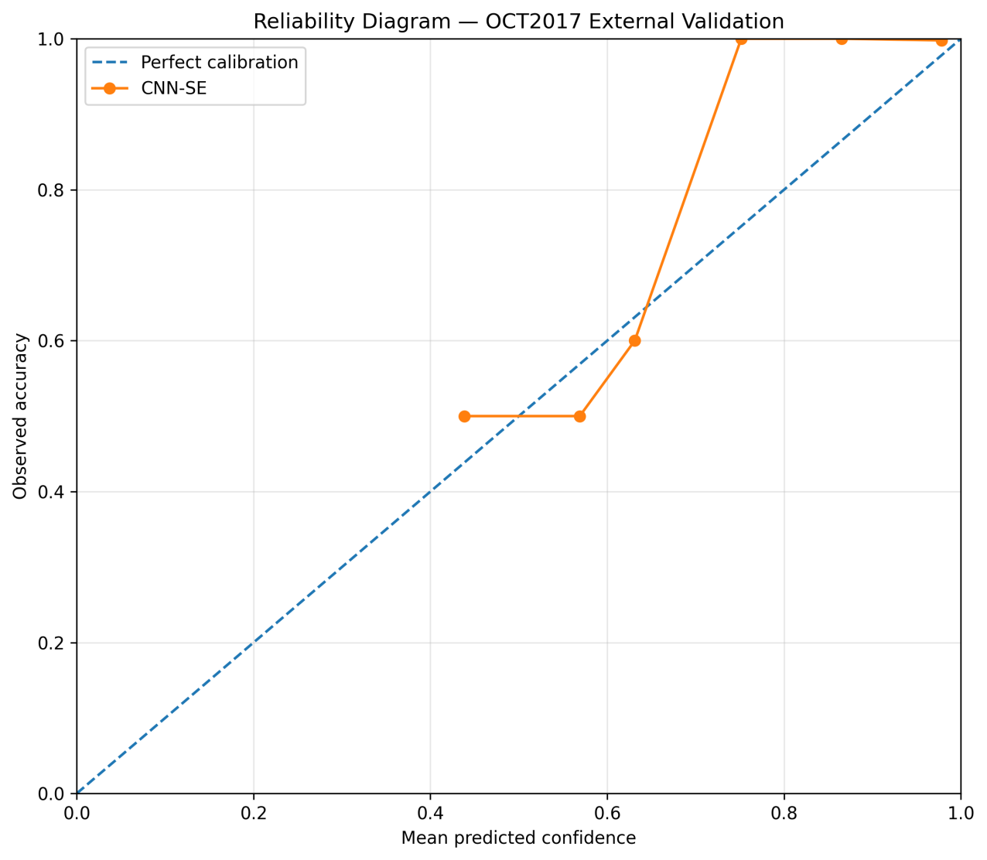
Figure 4. Reliability diagram plotting observed accuracy against mean predicted confidence. The maximum calibration error (0.2485) is observed in the sparsely populated 0.7–0.8 confidence bin.
A detailed breakdown of the model's confidence distribution is provided in Table 5, which groups predictions into discrete bins to highlight specific ranges where the model becomes miscalibrated.
Table 5. Calibration metrics segmented by confidence bins, displaying the absolute gap between mean predicted confidence and observed accuracy.
Confidence bin | Images | Mean confidence | Observed accuracy | Absolute gap
0.4–0.5 | 2 | 0.439 | 0.500 | 0.061
0.5–0.6 | 2 | 0.569 | 0.500 | 0.069
0.6–0.7 | 5 | 0.631 | 0.600 | 0.031
0.7–0.8 | 6 | 0.752 | 1.000 | 0.248
0.8–0.9 | 27 | 0.865 | 1.000 | 0.135
0.9–1.0 | 926 | 0.978 | 0.998 | 0.020

4.7 Computational measurements
Table 6 compares the CNN–SE architecture against standard lightweight baselines—MobileNetV2 [10], EfficientNetB0 [11], and NASNetMobile [12] across multiple hardware and efficiency metrics to contextualize its deployment feasibility.
Table 6. Computational performance, parameter efficiency, and inference benchmarks comparing the CNN–SE architecture with baseline mobile networks
Model | Params (M) | FLOPs (G) | FP32 weights (MB) | Latency (ms/img) | Throughput (img/s) | Peak GPU memory (MB) | CPU RSS increase (MB)
Proposed CNN-SE | 1.232 | 6.123 | 4.70 | 81.79 | 12.23 |  | 1.91
MobileNetV2 | 2.268 | 0.613 | 8.65 | 116.46 | 8.59 |  | 0.06
EfficientNetB0 | 4.060 | 0.801 | 15.49 | 213.44 | 4.69 |  | 0.88
NASNetMobile | 4.278 | 1.146 | 16.32 | 482.16 | 2.07 |  | 0.00
The CNN–SE model has approximately 1.232 million parameters and an estimated FP32 parameter-memory footprint of 4.70 MB. In the benchmark, it has the highest reported FLOP count among the four models. It has fewer parameters and a smaller stored parameter footprint than the three listed baselines, while its measured latency and throughput are better than the baselines in this particular benchmark. These latency results are hardware- and implementation-dependent.

5. Discussion
The CNN–SE model achieved 99.38% accuracy on the evaluated 968-image OCT2017 subset after training on OCT-C8, with no recorded fine-tuning during the external evaluation. The five-seed results demonstrate that this performance is not limited to one random seed. Class-wise results are uniformly high, allowing the six errors to be isolated and examined in detail.
The results do not establish generalisation across hospitals, scanners, countries, patient demographics, or clinical workflows. The test set is one external dataset source, and repeated seeds reuse that same set. The class mapping also restricts evaluation to four of the model's eight output classes. The study does not include a controlled ablation to quantify the independent contribution of SE blocks, CLAHE, denoising, or augmentation. It does not establish clinical utility, improved patient outcomes, or suitability for autonomous diagnosis.

6. Limitations
- Only one external test source is represented in the saved evaluation. The five-seed experiment does not replace multi-site external validation.
- The model has eight output classes, but the external evaluation maps the predictions to four target classes. The mapping is reasonable for a restricted task, but it must be clearly stated.
- The saved results use 968 images with 242 per class. The dataset version and the reason for this test-set composition must be identified precisely.
- The saved result package does not by itself document all acquisition devices, patient-level grouping, or potential dependence between images. Image-level independence should not be assumed without dataset provenance.
- No controlled ablation isolates the contribution of SE blocks or individual preprocessing operations.
- Calibration estimates use a small number of bins and some bins contain very few images. ECE and MCE are sensitive to binning.
- The computational benchmark has no reported peak GPU memory values, and latency measurements differ between evaluation artifacts. Hardware and software details need to be reconciled.
- The study is retrospective and image-level. It does not assess clinical workflow, patient-level outcomes, prospective performance, or clinician interaction.

7. Future Research Directions

7.1 Multi-source external evaluation
The highest priority is evaluation on more than one independent external dataset. Future work should include images from different institutions, scanners, acquisition protocols, and patient populations. Where possible, results should be reported separately for each source before any pooled estimate is calculated. Patient-level separation and duplicate-image checks should be documented.

7.2 Domain-shift and image-quality stress testing
Future experiments should test sensitivity to contrast changes, noise, blur, compression, cropping, and changes in image dimensions. The aim should be to identify when performance degrades and which types of shift are most consequential. Any synthetic corruption study should be labelled as a stress test and should not be presented as a substitute for external clinical data.

7.3 Controlled ablation studies
Ablation experiments should compare the full model with variants that remove SE blocks, CLAHE, median filtering, label smoothing, and augmentation, one factor at a time where feasible. The same data splits, seeds, stopping rules, and evaluation metrics should be used. This would clarify whether each design choice contributes to generalisation or whether performance is mainly driven by dataset properties and training choices.

7.4 Confidence calibration and selective prediction
Future work should compare calibration methods such as temperature scaling on a held-out validation set. Calibration should be assessed using reliability diagrams, Brier score, log loss, and ECE with sensitivity analysis over binning choices [9]. Selective prediction could also be studied: cases with low confidence or high uncertainty may be referred for human review rather than assigned a definitive automated label. Before any new training, the existing five-seed prediction files can also be analysed to determine whether errors recur across seeds, how often class probabilities change for the same image, and whether the reported calibration conclusions are stable under alternative binning choices. These are analyses of saved outputs, not new model experiments.

7.5 Clinically informed error analysis
The six existing errors should be reviewed by qualified retinal specialists if the images and usage permissions allow it. A future error taxonomy could record disease overlap, poor image quality, artefacts, uncertain reference labels, and possible preprocessing effects. The analysis should avoid inferring clinical causes from model probabilities alone.

8. Conclusion
This analytical study evaluated the cross-dataset generalisation of a CNN–SE model trained on OCT-C8 and tested on a four-class OCT2017 subset. The single-model evaluation achieved 99.38% accuracy on 968 images, while the five-seed mean was 99.28% with a standard deviation of 0.10 percentage points. The results also outline six classification errors, generally high confidence, and calibration behaviour that warrants deeper examination. The computational benchmark indicates a compact parameter count but does not support a claim that the model is superior on every measure of computational efficiency. While the model demonstrates high discrimination on the evaluated test subset, generalisability remains limited by the use of one external source, restricted class mapping, lack of controlled ablation, and incomplete memory benchmarking. Future work must prioritise multi-source external evaluation, domain-shift testing, comprehensive calibration, clinically informed error review, and reproducible computational comparisons.

References
[1] D. S. Kermany et al., “Identifying Medical Diagnoses and Treatable Diseases by Image-Based Deep Learning,” Cell, vol. 172, no. 5, pp. 1122-1131.e9, Feb. 2018, doi: 10.1016/j.cell.2018.02.010.
[2] J. R. Zech, M. A. Badgeley, M. Liu, A. B. Costa, J. J. Titano, and E. K. Oermann, “Variable generalization performance of a deep learning model to detect pneumonia in chest radiographs: a cross-sectional study,” PLoS medicine, vol. 15, no. 11, p. e1002683, 2018.
[3] P. Dave, N. Domadiya, and J. Patel, “Automated Retinal Disease Classification from OCT Images Using a Lightweight CNN–SE Architecture,” j.electron.electromedical.eng.med.inform, vol. 8, no. 4, pp. 1439–1455, Oct. 2026, doi: 10.35882/jeeemi.v8i4.1991.
[4] J. Hu, L. Shen, and G. Sun, “Squeeze-and-Excitation Networks,” in 2018 IEEE/CVF Conference on Computer Vision and Pattern Recognition, Salt Lake City, UT: IEEE, Jun. 2018, pp. 7132–7141. doi: 10.1109/CVPR.2018.00745.
[5] A. S. Tejani et al., “Checklist for Artificial Intelligence in Medical Imaging (CLAIM): 2024 Update,” Radiology: Artificial Intelligence, vol. 6, no. 4, p. e240300, Jul. 2024, doi: 10.1148/ryai.240300.
[6] E. Begoli, T. Bhattacharya, and D. Kusnezov, “The need for uncertainty quantification in machine-assisted medical decision making,” Nature Machine Intelligence, vol. 1, no. 1, pp. 20–23, 2019.
[7] W. B. Glenn and others, “Verification of forecasts expressed in terms of probability,” Monthly weather review, vol. 78, no. 1, pp. 1–3, 1950.
[8] M. Vijayan, G. Veerapu, and N. J. S., “A spatial adaptive multi-scale ConvNeXt framework for robust, calibrated, and statistically validated multi-class retinal OCT classification,” Front. Artif. Intell., vol. 9, p. 1898978, Aug. 2026, doi: 10.3389/frai.2026.1898978.
[9] C. Guo, G. Pleiss, Y. Sun, and K. Q. Weinberger, “On calibration of modern neural networks,” in International conference on machine learning, PMLR, 2017, pp. 1321–1330.
[10] M. Sandler, A. Howard, M. Zhu, A. Zhmoginov, and L.-C. Chen, “Mobilenetv2: Inverted residuals and linear bottlenecks,” in 2018 IEEE/CVF conference on computer vision and pattern recognition, Ieee, 2018, pp. 4510–4520.
[11] M. Tan and Q. Le, “Efficientnet: Rethinking model scaling for convolutional neural networks,” in International conference on machine learning, PmLR, 2019, pp. 6105–6114.
[12] B. Zoph, V. Vasudevan, J. Shlens, and Q. V. Le, “Learning transferable architectures for scalable image recognition,” in 2018 IEEE/CVF conference on computer vision and pattern recognition, IEEE, 2018, pp. 8697–8710.

